HAMPSHIRE SCHOOL GAMES
#DAILYCHALLENGE - SCHOOL GAMES MARK MAY: 11TH – 15TH MAY

Name: Year Group: School:

WARM UP GAME – ROLL THE DICE
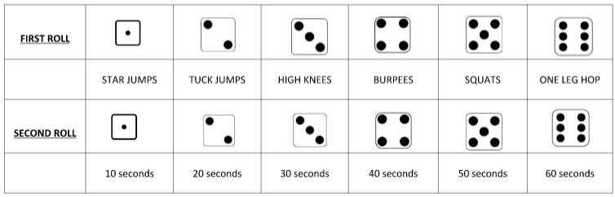

- All you need for this warm up game is yourself, any family members that are free, and a dice.
- If you do not have a dice then why not make your own, or use a dice on the internet.

- Take it in turns to have your go, as soon as you have rolled the next person goes and so on.

- Each participant will need to roll the dice twice, the first roll will determine the exercise you will be doing, and the second roll will determine the length of time you will be doing that exercise.

- Keep on going for 20 minutes, how many of the exercises can you get through in that time.
This week’s challenges all focus on the School Games Values of Determination, Passion, Honesty and Self Belief

ACTIVITY | DESCRIPTION  EACH ACTIVITY TO LAST 5 MINUTES | MONDAY | TUESDAY | WEDNESDAY | THURSDAY | FRIDAY
MOVE IT MONDAY  ATHLETICS:  SPEED BOUNCE  Object to jump over | - Find an object that to jump over i.e. cereal box or rolled up towel.  - Place your object on the floor and jump sideways over it. Make sure you jump and land using two feet.  - KS1 – you have 15 seconds, KS2 – you have 20 seconds for your challenges.  - Have a few goes, with a rest, and record your highest score?
TRY IT TUESDAY  ATHLETICS:  AGILITY RUN  4 markers | - Place your 4 markers on the floor  - KS1 – each marker 1.5m apart  - KS2 – each marker 2m apart  - How quickly can you run in and out of your markers 4 times?  - Have a few goes, with a rest, and record your fastest score.
WORK OUT WEDNESDAY  TENNIS:  BALL CONTROL  Ball, Racket | KS1 – you only need a ball and a hard surface to work on.  - You need to bounce the ball on the floor, then catch it, throw the ball in the air and then catch it and repeat. Bounce, catch, throw, catch, bounce, catch, throw, catch until you lose control of the ball.  KS2 – you will need a ball and a racket of some kind (hand, racket)  - You need to bounce the ball on the floor and then ‘tap it’ in the air, allow the ball to bounce again and then tap it again, keep repeating bounce, tap, bounce, tap until you lose control of the ball  - Count how many you can do before losing control of the ball  - Have a few goes and record your highest score
TRAIN IT THURSDAY  TENNIS  BALL CONTROL & MOVEMENT SKILLS  Ball, Racket & 2 markers | - You are doing the same challenge as yesterday, however this time you will be doing it whilst moving.  KS1 – you will need two markers 2m apart.  KS2 – you will need your markers 4m apart.  - Repeat the challenge you were doing yesterday but this time you need to move between your markers.  - Count how many lengths you are able to do before you lose control of the ball.  - Have a few goes and record your best score.
FRIDAY FINISHER | - Repeat all the activities and try to beat your score! Good Luck!
Challenges should be done between 9am and 3pm – send through your results to me in order to earn a point for your school. You can take a picture and send it to Holly Shirley: email holly.shirley@mountbatten.hants.sch.uk or via Facebook Messenger @TestValley SchoolGames. There is also a Hampshire SGO Twitter @HampshireSGO and Facebook page.

