Topic Home Learning – History
This time in all our lives at the moment is like nothing we have ever experienced. Our children have been superb at adapting to learning at home and we are so proud of them for being ‘Stay at home Superheroes’. We thought it might be a nice idea to mark this time in some way that is memorable to you and your family. Below are some suggestions and keepsakes you could create as a family which we are sure you will look back on and remember this special time again one day.
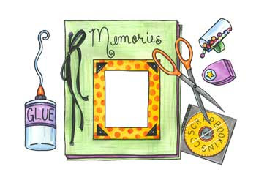
Make a family scrapbook
We are sure you have gathered many photographs and art work of your memories so far from the last five weeks. Perhaps you and your child could arrange them in a scrap book. Encourage your child to make speech bubbles or captions to go with each picture. You could include newspaper cuttings if you wish – where possible try and focus on some of the more positive headlines that have occurred in the news such as the beautiful rainbow pictures in people’s houses and Captain Tom Moore raising millions for our NHS. In addition, your child could draw their favourite memory during their time at home.
Make a time capsule
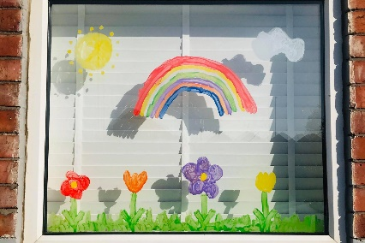
Rather than a scrapbook you may prefer to create a family time capsule. Time capsules are containers of some kind which hold a selection of objects, picked because they have a special meaning in the time that we’re living in. Currently, we are all living through an important moment in history. Many people want to help future generations learn about this time using time capsules which is full of things that show what life under lockdown was like. This website gives you step by step instructions of how to make a time capsule and the types of objects you may include. https://www.goodtoknow.co.uk/family/things-to-do/covid-19-time-capsule-538121

Make a saltdough handprint plaque
You may have already seen many examples of these online and we think they are a wonderful family keepsake in which you can display for years to come in your home if you choose to. Here is a link with the recipe. https://www.heart.co.uk/lifestyle/parenting/nursery-shares-craft-idea-coronavirus/
Start a diary or write a letter.
Even if your child just writes a few entries try and capture how they are feeling and encourage them to think of as many positives as possible. Maybe they could even write some top tips for anyone reading this in the future for how to stay happy during a lockdown. Alternatively, your child may like to write a letter to themselves about their experiences for them to open in 20 years time.

Make a wish jar – ‘We’ll make them come true after this tough time is through.’
Encourage your child to write down things that they are most excited to do when this is over. Talk about what the wishes might be i.e. hugging grandparents, visiting friends and family, going to the park and being at school again . You may also like to start a thankful jar and encourage your child to jot down all the things they are thankful for during this time such as the sunshine, exploring mini beasts in the garden, wearing pyjamas more often and learning a new skill.
Let the children interview the parents
Here is a fun template you might like to use.

We hope these activities are useful to you and as always we can’t wait to see your child’s wonderful work. Thank you for all you have shared so far.

