Maths
This week we are sending you a link with a sequence of Maths lessons for you to follow and have a go at, begin with Summer Term Week 1:
https://whiterosemaths.com/homelearning/year-1/
Each video starts with a flashback 4 set of questions which recaps the learning that children have already experienced this year. The video will need to be paused at the right times to allow children time to work out the answers.
Here are some challenges you could try once you have finished each lesson:
Lesson 1 – Learning Objective: To make doubles
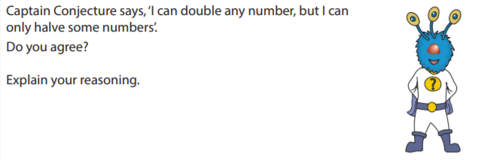
Lesson 2 – Learning Objective: Make equal groups by grouping
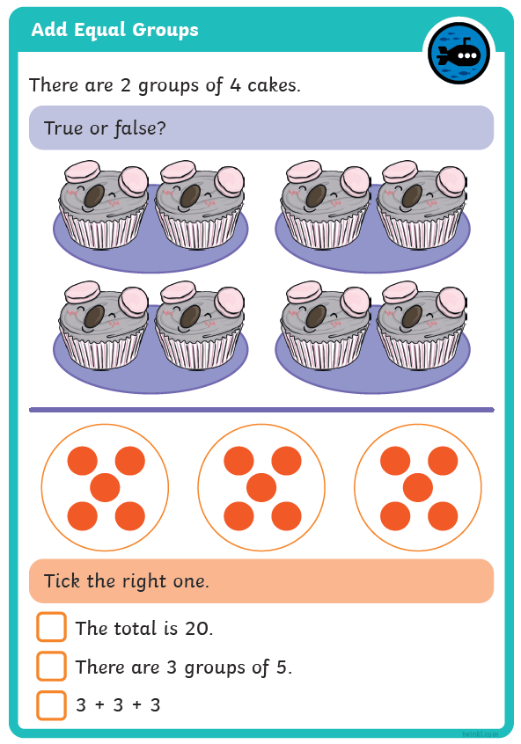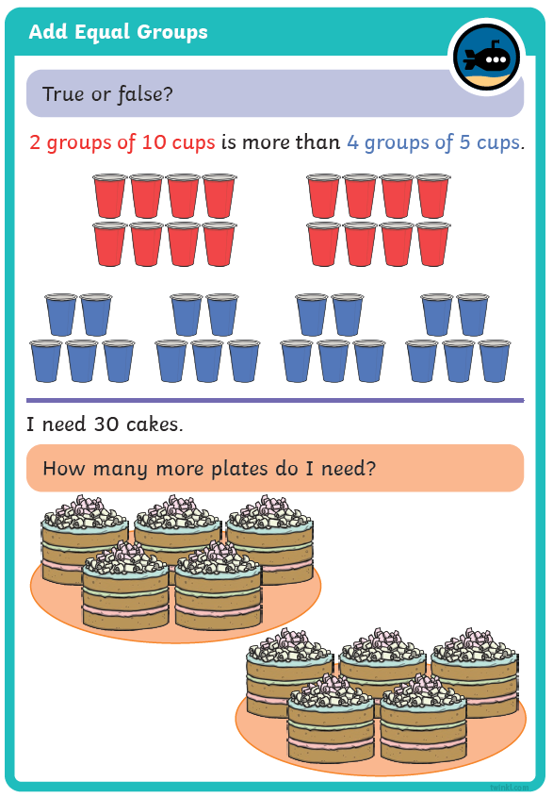

Lesson 3 – Learning Objective: Make equal groups by sharing
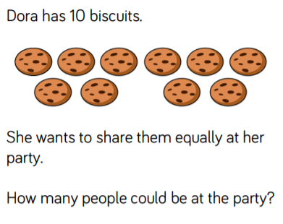
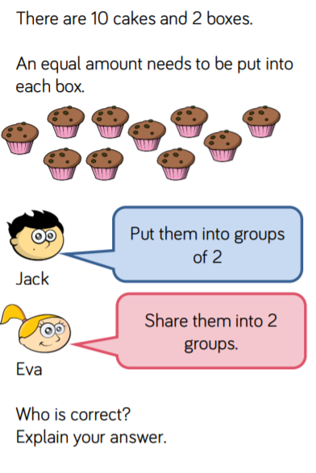

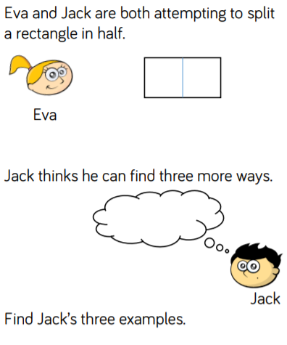
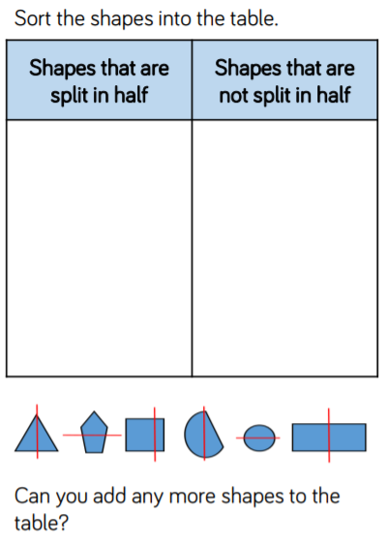
Lesson 4 – Learning Objective: Understand and find a half

Let us know how you get on using our class email.

