Phonics-
Helpful Website:
www.phonicsplay.co.uk
Username- march20
Password- home

Keep up the good work practising your phonics at home!
Your Phase 5 sound to recap this week is ‘Alternative ee’…
Sound of the Day | ‘ee’ like in green. | ‘ea’ like in pea. | ‘ey’ like in money. | ‘e-e’ like in even. | Recap Day  Can you remember all of the alternative ‘ee’ sounds you have practised this week?  Tell an adult all of the different ways you can write the ‘ee’ sound.  Watch this Alphablocks video to refresh your memory…  https://www.youtube.com  /watch?v=zsPPggEUaak
Tricky words-  Can you read and spell me? | people  could  don’t | people  could  don’t | people  could  don’t | people  could  don’t
Watch me! | https://www.youtube.com/  watch?v=qfM7Hz7US0U | 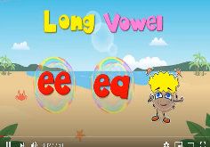  https://www.youtube.com/  watch?v=3PJGqbCeRU4 | https://www.youtube.com/  watch?v=nFGBy8uDnjI | https://www.youtube.com/  watch?v=kFuETDoqVnA  and  https://www.youtube.com/  watch?v=L7faYbILI1s  (Full explanation and recap of all split digraphs)
Have a go at reading these words.  If you are unsure what a word means don’t forget to ask an adult to help you! | deep  weep  meet  sleep  trees  queen  squeeze breeze  freeze | leak  meal  beans  beach  peach  speak  jeans  wheat  repeat | honey  valley  jockey  money  monkey  donkey  turkey  chimney  journey | even  these  swede theme  delete  athlete  concrete  compete  evening
Now choose two of the words above to write in a sentence.
Extra Challenge- Can you write 4 words in a sentence together?
Time to apply | 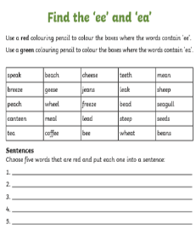  Open the ACTVITY 1 link on the website | 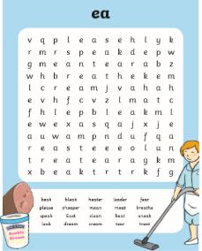  Open the ACTVITY 2 link on the website | 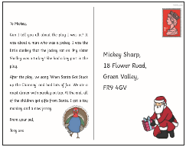  Open the ACTVITY 3 link on the website | 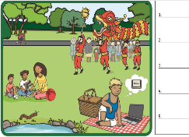  Open the ACTVITY 4 link on the website | 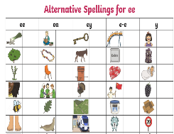  Open the ACTVITY 5 link on the website
If you are able to you may like to print some of these activities.  Don’t worry if this is not possible just use a plain sheet of paper! | Find the ee/ea words. Colour the ee words in red and the ea words in green.  Challenge- Can you write your 5 chosen ee/ea words in a sentence. | ‘ea’ wordsearch. Can you spot all of the hidden ‘ea’ words? Tick them off on your word bank as you go.  If you are unable to print either spot on screen or why not make your own ea wordsearch. | ‘ey’ phoneme spotter postcard. Hidden in this postcard are lots of words containing the ‘ey’ sound you might like to use a pen to highlight the words you find or read through the postcard and give a thumbs up every time you read a ‘ey’ word. | Look carefully at this scene.  Can you find the 5 hidden e-e words and write them down correctly?  (Top tip if you get stuck!  One of these words is written as e-e but sounds more like ‘ear’ when you say it.) | Look at the pictures can you write the word each picture shows using the correct ‘ee/ea/ey/e-e’ sound?  Alternatively you might like to make your own grid using A4 paper and record your words under each heading ee/ea/ey/e-e.
Sentence of the day!  Can you spot the hidden Phase 5 sounds within each sentence? | I went into a deep sleep and had a dream about a sneezing tree. | I sat on the beach eating a juicy peach some wheat and a tin of beans. What a strange meal! | A monkey ran away with some money into the valley but the jockey chased after him on his donkey. | Eve and Steve were extremely good athletes who liked to compete in evening races. | Can you think of your own sentence using the sounds you have learnt this week?
Reminder:
It is important to keep practising reading and writing Common Exception words. A list of these can be found here, you may also like to look at the list of Year 2 words to extend your learning!
(Use Free Access Code- UKTWINKLHELPS)
https://www.twinkl.co.uk/resource/t-l-5089-new-common-exception-words-years-1-and-2-word-mat?sign_in=1
Spellings
Have a go at practising writing these spellings.
Ask a grown up to test you at
the end of the week!
Remember you can have lots of fun practising in different ways. Here are some examples for you



