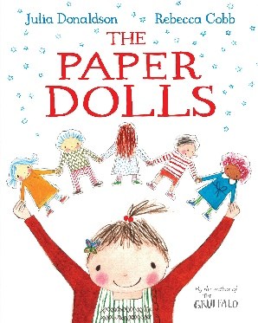
The Paper Dolls by Julia Donaldson
Areas of the Year 1 reading curriculum covered:
To recognise and join in with predictable phrases.
To discuss word meanings, linking new meanings to those already known.
To explain clearly their understanding of what is read to them.
To be encouraged to link what they read or hear to their own experiences.

Enjoy the story of ‘The Paper Dolls’ read by the author herself:
https://www.youtube.com/watch?v=wGoYFuq8sBc
- Which parts of the story are repeated? As you listen to the story can you join in with any parts? Listen to the story for a second time, is it easier to join in with the repeated parts?

- ‘Then they lay on a rooftop and stared at the stars, til a tiger slunk out of his den”

What do you think the meaning of the word slunk is? If you are not sure you could use this online dictionary to find a definition: https://kids.britannica.com/kids/browse/dictionary

Can you think of any other words with a similar meaning that the author could have used instead of ‘slunk’? Re-write the sentence including your new vocabulary choice.

- You can see the front cover of ‘The Paper Dolls’ at the top of this page. Design the back cover of the book including a blurb (describe the main things that happen in the story).

- If the paper dolls floated into your memory what would they find there? Draw and label a picture to show me. Are there any new lovely memories from your time at home over the last few weeks that they might see?

- Make your own set of paper dolls using the guidelines at the beginning of the video clip. Can you choose them names that rhyme? What adventures could your paper dolls go on in your home? Maybe you could write your own ‘The Paper Dolls’ story.

